- 5.3km run - https://connect.garmin.com/modern/course/48838785#
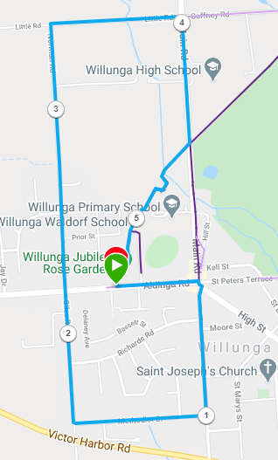
Directions:
- From the Rose Garden run to the main Street and then turn right onto St Andrew Terrace
- At 1km turn right into Methodist St
- Continue following this road around the corner to the right (changing to Giles Road) until you reach the main (Aldinga) road
- Continue across Aldinga Road onto Norman Road until the T-Section (Little Road)
- Turn right into Little road and follow to , continuing until the Shiraz Trail
- Turn right onto the Shiraz trail and follow back to the Rose garden
- 12.3km run - https://connect.garmin.com/modern/course/9030190
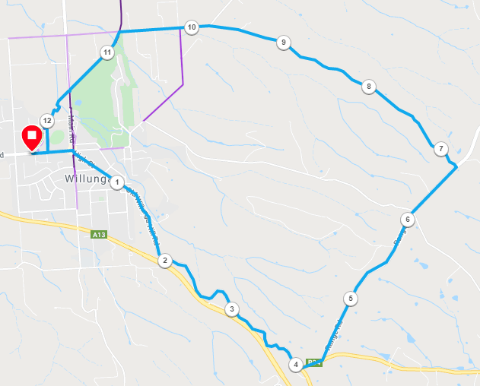
Directions:
- From the Rose Garden run to the main Street and then continue along the main street to the right (High St)
- Continue along this road onto Old Willunga Hill Road all the way until the top!
- At the top of the hill turn left into Brookman and then after 200 metres turn left into Range Road
- Continue along Range road, past Taylor’s hill road and then (6.7KM) turn left into Kings Hill Road (IT LOOKS LIKE A DRIVEWAY….DON’T MISS IT)
- Follow Kings Hill Road to the bottom and then turn left at the power sub-station
- Follow until the Shiraz trail crosses the road and turn left onto the trail
- Follow Shiraz trail back to the Rose Garden

- 22.2km run - https://connect.garmin.com/modern/course/48838944#
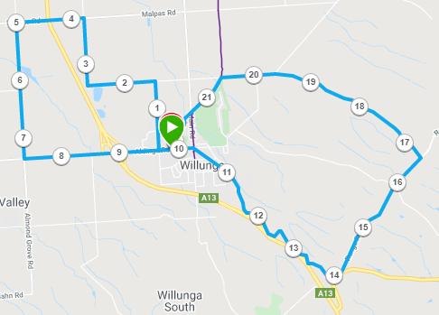
Directions:
- From the Rose Garden, Run West (Towards Aldinga) and turn right into Norman Road
- Follow till T-Section (1.8km) and turn left into Little Road
- Follow the road and continue as it turns to the right until you reach Malpas road (3.75km) and turn left
- Cross over the main road and then turn left at the next road, into California Road (5km)
- Continue until you reach Aldinga road (7.3km) and turn left and continue until the rose garden
With 10k runners:
- From the Rose Garden run to the main Street and then continue along the main street to the right (High St)
- Continue along this road onto Old Willunga Hill Road all the way until the top!
- At the top of the hill turn left into Brookman and then after 200 metres turn left into Range Road
- Continue along Range road, past Taylor’s hill road and then (16.5KM) turn left into Kings Hill Road (IT LOOKS LIKE A DRIVEWAY….DON’T MISS IT)
- Follow Kings Hill Road to the bottom and then turn left at the power sub-station
- Follow until the Shiraz trail crosses the road and turn left onto the trail
- Follow Shiraz trail back to the Rose Garden

