**SRG Run 6 – 5.0km Pimpala run**

* **5.0km course**

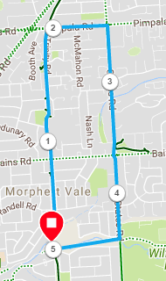

Directions:

1. Starting at the park, head up the Bike track, cross Bains road and continue to Pimpala Rd (Hungry Jacks/Junk Food Corner)
2. Turn right and follow Pimpala until States Road (Roundabout with shops on left and park on right)
3. Turn right and follow States Rd, across Bains Rd until Christies Creek (opposite Sports fields)
4. Turn right into Suffolk Drive until the school then take tunnel back to the park

**SRG Run 6 – 10.2km Pimpala run**

* **10.2km course**

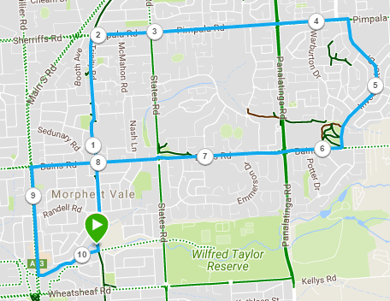

Directions:

1. From the park head up the Bike track, cross Bains road and continue to Pimpala Rd (Hungry Jacks/Junk Food Corner)
2. Turn right and follow Pimpala across States Road and to Panatalinga Rd. Cross Panatalinga and continue along Pimpala till you go through a roundabout near the shopping centre on left (Park area on Right)
3. Turn right at the roundabout into Investigator Drive. Follow road all the way to the end (Roundabout T-Section with Bains Road)
4. Turn right into Bains road. Cross Panatalinga (Woodcroft Shopping centre), States Road (Corner shops) and run till Main South Road lights
5. Turn left and go down-hill till Emu hotel
6. Turn left into the Emu hotel carpark and follow the track back to the park.

**SRG Run 6 – 21.4km Pimpala run**

* **21.4km course**

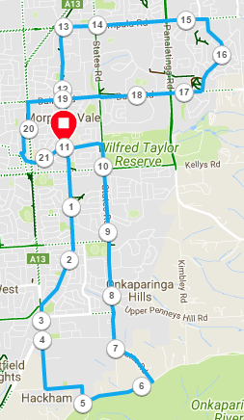

Directions:

1. Follow the bike-track southwards, crossing Wheatsheaf and Doctors roads.
2. Turn left when you reach Main South road, passing the shops and then take the side road into Gates Road and up the hill
3. Turn left into Hepenstal road and follow it till you reach Piggot Range Road.
4. Turn left and continue until States road and turn left
5. Continue along States road until you pass Duval St, then turn left along the bike track back to the park.
6. (Joining 10km runners) Continue along the Bike track, cross Bains road and continue to Pimpala Rd (Hungry Jacks/Junk Food Corner)
7. Turn right and follow Pimpala across States Road and to Panatalinga Rd. Cross Panatalinga and continue along Pimpala till you go through a roundabout near the shopping centre on left (Park area on Right)
8. Turn right at the roundabout into Investigator Drive. Follow road all the way to the end (Roundabout T-Section with Bains Road)
9. Turn right into Bains road. Cross Panatalinga (Woodcroft Shopping centre), States Road (Corner shops) and run till Main South Road lights
10. Turn left and go down-hill till Emu hotel
11. Turn left into the Emu hotel carpark and follow the track back to the park.