SRG 4.9km Aldinga Beach Xmas run 2016

https://connect.garmin.com/modern/course/14017503

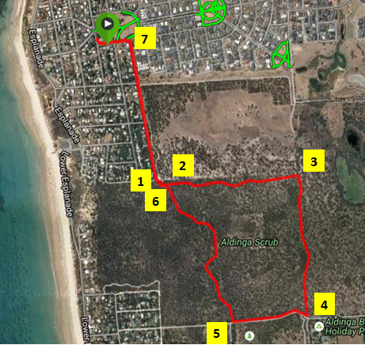

DIRECTIONS:
- Turn into Dover Street and follow all the way to the end. There is a carpark on the left and the entrance to the park is at the carpark entrance.
- Once you have entered the park continue past the sign and map on the left and take the track on the left that has been marked.
- Follow this track (the last section follows a fence on the right) until the end of the fence.
- Turn right and continue along the fence keeping it to your right and when the fence ends continue on the path until you find yourself looking at an intersection with a caravan park across the road.
- Stay in the park and turn right onto the main fire track up the hill. Continue on this fire track until you reach a brown post on your right, (If you reach the otherside of the park you have gone too far) and turn onto this track.
- Follow this track all the way back to the entrance of the park at Dover Street ignoring any side tracks. Exit the park at the same point that you entered and continue north on Dover Street.
- At the end of Dover Street, turn left and you should see the Scout Hall……

SRG 9.9km Aldinga Beach Xmas run 2016

https://connect.garmin.com/modern/course/14017532

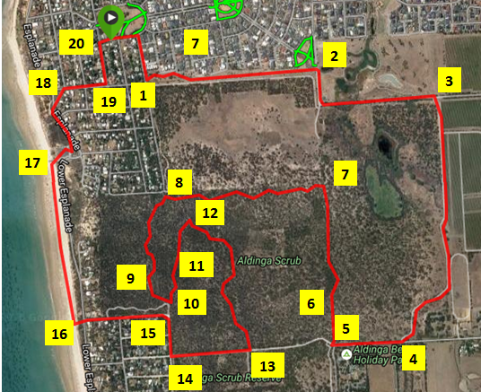
DIRECTIONS:
- Turn into Dover Street and turn left onto gravel track at the bottom of hill just after the last house.
- Follow this track for approx 1km then turn right onto dirt road before entering wetlands. Continue on this road turning left at the next corner and continue until the gate across this road.
- Turn sharp right and jump over the gate and continue on this track until you reach another gate, jump over this and turn right onto Cox Road.
- Follow the bitumen road until you reach the caravan park on the left.
- At this point go straight ahead around the gate and enter the park BUT turn hard right and look for a track.
- Follow this track when you reach a fence you should continue straight ahead and follow this fence to the end.
- At the end of the fence turn left and continue along the fence for approx 50m and follow tape back onto the trail. Follow this trail until you come out onto a sandy track.
- At this point you will need to turn right and follow this track for approx 50m. (you are now at the entrance into the park and there is a sign with a map on your right but you need to ignore this. Stay on the left track in the park and look for green posts with numbers. Follow numbers 1-11.
- When you reach number 11 IGNORE the arrow and continue to the right and follow the track until it comes out on a gravel section.
- Follow the gravel track to the left and back onto a single track on the left.
- Once you get to the top of the hill (there is a post with number 15 on it) you will see a few tracks intersecting this area with a lookout to the right. Continue straight ahead and follow track until you reach a t-junction with 3 posts.
- Turn right and follow this trail until you reach a brown post. Take the track on the left and continue until you reach a wide fire track.
- Turn right and follow the fire track to the edge of the park and exit the park.
- Turn right and follow the dirt road up the hill and turn left onto Quondong Road
- Continue on Quondong Road down the hill and cross over Lower Esplanade. Look for steps down onto the beach and follow these.
- Once on the beach turn right and run along the beach and exit at the Boat ramp.
- Exit up the ramp, through the car park and turn left onto the Esplanade.
- Follow the Esplanade to Palmer Street and turn right.
- Follow Palmer Street to Storey Road and turn left.
- Follow Storey Road to the top and you have reached your destination…….

