Onkaparinga River Pringle farm and river edge runs
- 5.6km course - https://connect.garmin.com/modern/course/46197506
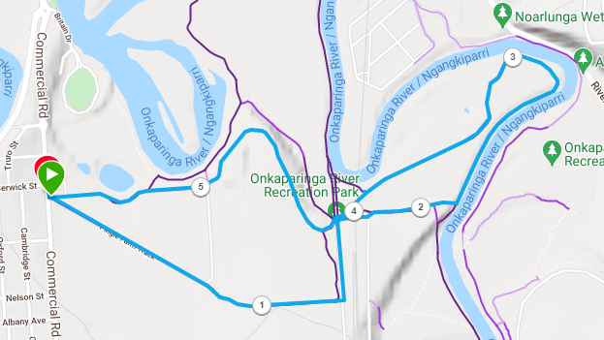
Directions:
- From the entry gate on Seaford Road, follow the diagonal track on the right side, along the fence-line and continue past the ruins until you reach a gravel road
- Join the road and turn left for approx., 200 metres and then go right through the gate and under the railway bridge
- Continue straight ahead towards the river (do not follow the right to the right)
- At the river’s edge, turn left and follow the track in a loop, until you get back to the same point under the railway bridge
- Go through the small gate and cross over the road, and through another small gate, then follow the main track, slightly towards the left all the way back to the start point
Onkaparinga River Pringle farm and river edge runs
- 10.0 km course - https://connect.garmin.com/modern/course/46197319
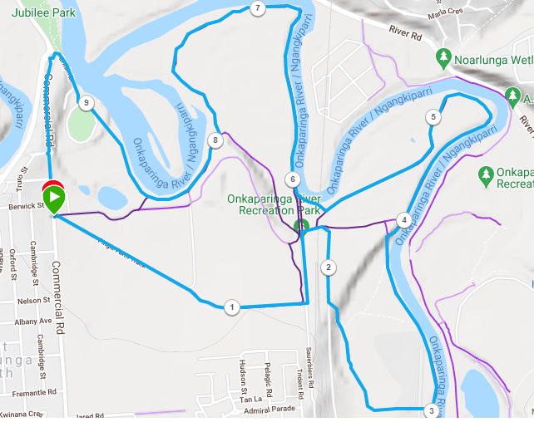
Directions:
- From the entry gate on Seaford Road, follow the diagonal track on the right side, along the fence-line and continue past the ruins until you reach a gravel road
- Join the road and turn left for approx., 200 metres and then go right through the gate and under the railway bridge
- Follow the gravel road to the right, then, after about 200metres, take a single track to the left and continue along the trails (somewhat) parallel to the gravel road
- When you reach the fence line, turn to the left and run until the river’s edge
- At the river turn left and continue to follow the track along the edge of the river until it loops back and returns to the railway bridge
- At the bridge, turn towards the right and continue along the track which follows the rivers edge, all the way until Onkaparinga Football oval
- Follow the road out of the football ground and continue until the roundabout
- Turn left and follow Commercial Road until you are back at the start point

Onkaparinga River Pringle farm and river edge runs
- 22.6 km course - https://connect.garmin.com/modern/course/46198732
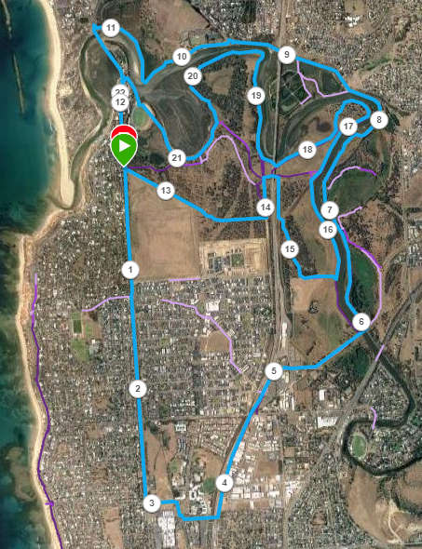
- Join the road and turn left for approx., 200 metres and then go right through the gate and under the railway bridge
- Follow the gravel road to the right, then, after about 200metres, take a single track to the left and continue along the trails (somewhat) parallel to the gravel road
- When you reach the fence line, turn to the left and run until the river’s edge
- At the river turn left and continue to follow the track along the edge of the river until it loops back and returns to the railway bridge
- At the bridge, turn towards the right and continue along the track which follows the river’s edge, all the way until Onkaparinga Football oval
- Follow the road out of the football ground and continue until the roundabout
- Turn left and follow Commercial Road until you are back at the start point
Directions:
- Follow Commercial road south until Seaford road and turn left
- Run to the railway overpass, then turn left onto the Coast to Vines trail
- Just after crossing over the river, take the track to the left and follow the river’s edge until River road
- Continue along River road until the roundabout (New Road) then go back onto the river edge trail and follow it until you get to Saltfleet bridge
- Turn left and cross the bridge, then continue along Commercial road until the start point of the run
- From the entry gate on Seaford Road, follow the diagonal track on the right side, along the fence-line and continue past the ruins until you reach a gravel road

