**Run A17 - 5.3km Southern Beaches run**

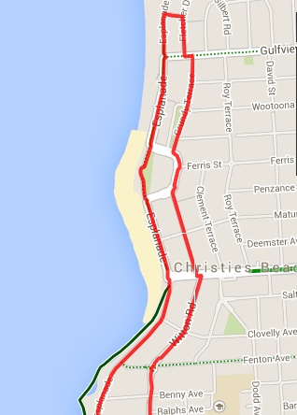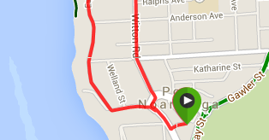

**Directions:**

1. Run out to Saltfleet road and then to the jetty
2. Continue along the Esplanade, over Witton Bluff to Christies Beach, and continue on
3. Just before reaching the end of the Esplanade (before the road turns to the right), turn right into Heather St and then right again into Fletcher Drive
4. At Gulfview road (T-Section) turn left and then right into Grundy Terrace, continuing around the back of the caravan park and on to Beach road
5. At Beach Road, turn left and right into Witton Road and follow to Port Noarlunga
6. At the end, ctoss over and go around the hotel, and return to the car park

**Run A17 - 10.7km Southern Beaches run**

**Directions:**

1. Run out to Saltfleet road and then to the jetty
2. Continue along the Esplanade, over Witton Bluff to Christies Beach, and continue on
3. Follow the track around past the SA water gates, and run along the coast until Marine Drive
4. Turn left and pass the entrance to the Marina, continuing on the gravel track until you run up the steep hill to O’Sullivan’s Beach
5. At the top, turn right across the car park, then continue straight ahead, along Baden Terrace – to the end
6. Turn right at the end into Morrow road and continue down the hill, and, at the bottom continue across the footbridge and keep going up the hill
7. Continue past the petrol station and run along Dyson road, past McDonalds until Murray road
8. Turn right and follow Murray road down the hill and back to the car park at Becks Bakery.

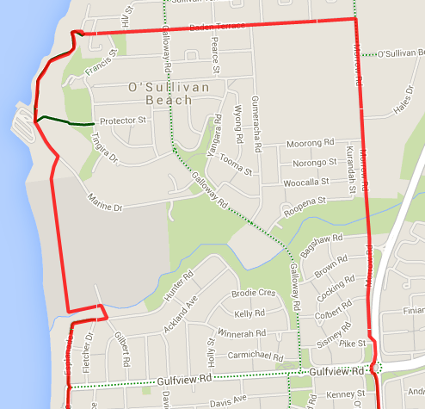 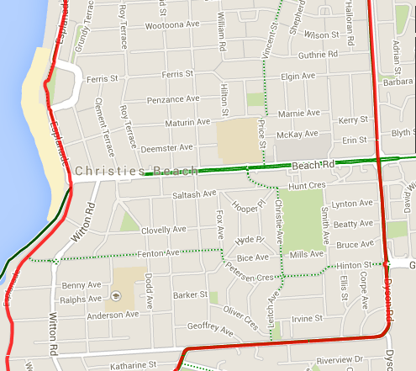 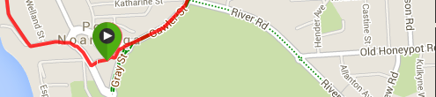

**Run A17 - 20.5km Southern Beaches run**

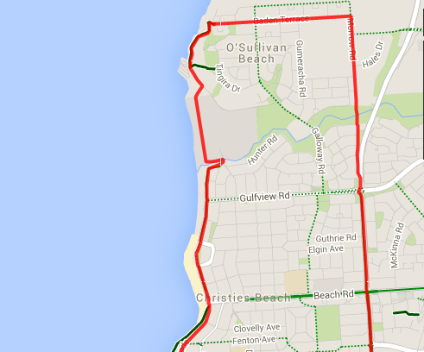 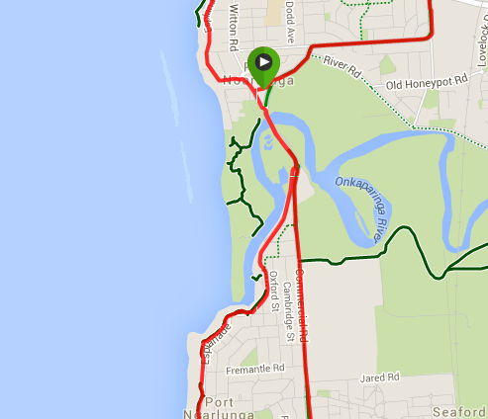 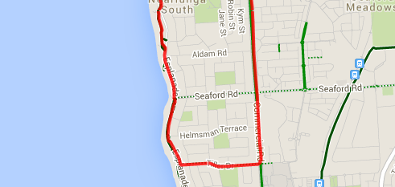

**Directions:**

1. From Beck’s Bakehouse carpark follow access road out to Saltfleet St and turn left
2. Cross Saltfleet bridge and continue through the roundabout along Commercial road
3. Cross Seaford road, and continue along Commercial road
4. Just after the McDonalds resturant turn right into Tiller Drive, and follow until the Esplanade bike trac
5. Turn right onto the coastal bike track and continue along this track, staying on the coast and river until you get back to Saltfleet bridge and return to the carpark the same way that you started

**JOIN WITH 10K RUNNERS**

1. Run out to Saltfleet road and then to the jetty
2. Continue along the Esplanade, over Witton Bluff to Christies Beach, and continue on
3. Follow the track around past the SA water gates, and run along the coast until Marine Drive
4. Turn left and pass the entrance to the Marina, continuing on the gravel track until you run up the steep hill to O’Sullivan’s Beach
5. At the top, turn right across the car park, then continue straight ahead, along Baden Terrace – to the end
6. Turn right at the end into Morrow road and continue down the hill, and, at the bottom continue across the footbridge and keep going up the hill
7. Continue past the petrol station and run along Dyson road, past McDonalds until Murray road
8. Turn right and follow Murray road down the hill and back to the car park at Becks bakery.