SRG Marino Lighthouse runs
- 5.8km course
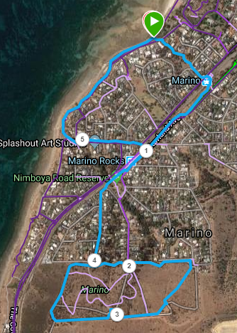
Directions:
- From the road, follow the track until you reach the railway line, and take the tunnel to reach the other side of the train tracks
- Turn right and follow the footpath alongside the train tracks
- After crossing over Jervois road (Level crossing), stay on the path near the railway line and then continue along the road as it swings away from the train tracks
- Follow road until you reach the entry to Mario Conservation park
- Just after passing the sign, turn left and follow the wide track until the top of the hill
- At the fence, take the track to the right and follow it as it continues down hill while crossing the park
- Once you reach the far fence, turn right and follow it till you reach the lighthouse
- Continue down the fence line and then turn to the right once you reach the bottom fence
- Continue to follow track until you get back to the park entry
- Turn left out of the park and follow the road back down to Marino Rocks railway station
- Pass the station and turn left into Jervois Road, at the level crossing
- Follow the road until you reach the car park at the bottom of the hill
- Turn right along the coastline and run back to the start.

SRG Marino Lighthouse runs - 9.75km course
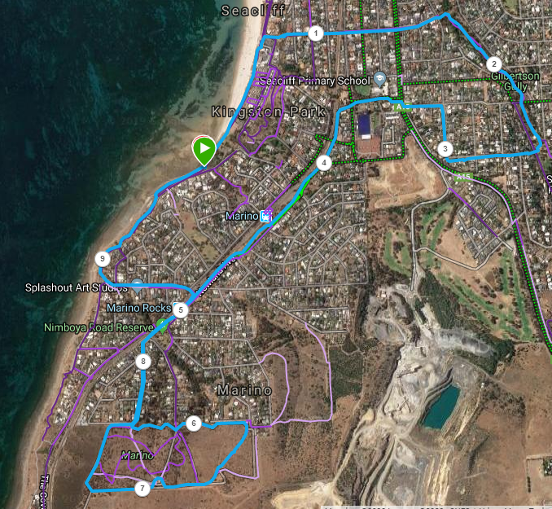
Directions:
- Run towards Seacliff Yacht club
- Just after the clubhouse and car park, turn right and go up the ramp, continuing along the roads straight ahead until you reach a t-section and entry to a track section
- Turn right and follow the track along the gully, continuing into the park once you reach it
- When you reach a playground and toilets in the park, turn tight and follow the road going away from the park (Hill St), continuing to follow it in an ‘L’ shape until you reach an intersection
- Turn left into Arthur St and follow it to the main (Brighton) road, then go right and left to cross over and continue through the school yard until you reach the next street (Kauri Parade) and then another right to the railway line - turn left and follow the footpath next to the train tracks
- Cross Singleton road and continue on - After crossing over Jervois Terrace (Level crossing), stay on the path closest the railway line and then continue along the road as it swings away from the train tracks at the end of the track
- Follow road until you reach the entry to Mario Conservation park
- Just after passing the sign, turn left and follow the wide track until the top of the hill
- At the fence, take the track to the right and follow it as it continues downhill while crossing the park
- Once you reach the far fence, turn right and follow it till you reach the lighthouse
- Continue down the fence line and then turn to the right once you reach the bottom fence
- Continue to follow track until you get back to the park entry
- Turn left out of the park and follow the road back down to Marino Rocks railway station
- Pass the station and turn left into Jervois Road, at the level crossing
- Follow the road until you reach the car park at the bottom of the hill
- Turn right along the coastline and run back to the start.

