5.0km Old Noarlunga trail run
https://connect.garmin.com/modern/course/30480741
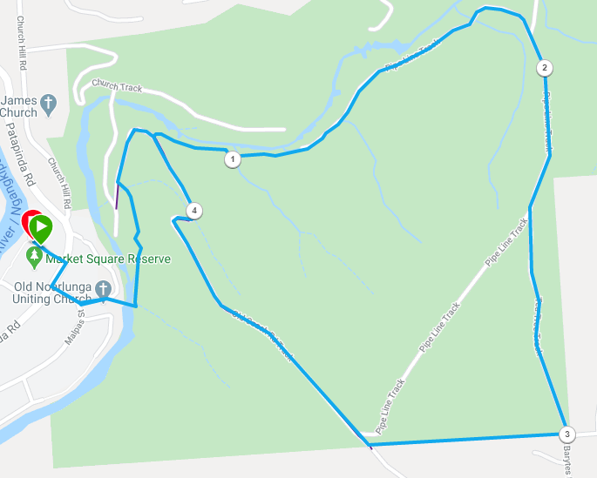
Directions:
- From the park, run towards the suspension bridge and cross over, turning left onto the single track
- Continue to follow the track as it continues along the wider trail/road to the bottom of Old Coach Road
- Take the Gorge track, to the left and continue to follow it till you reach the Pipeline
- Run up the hill following the pipeline track until you reach the top fence
- Turn right and follow the fence until the park gate (left) and Old Coach Road (Right)
- Turn Right and follow Old Coach Road back down the hill
- At the bottom, continue to the left back to the suspension bridge and the park

10.2km Old Noarlunga trail run
https://connect.garmin.com/modern/course/30480849
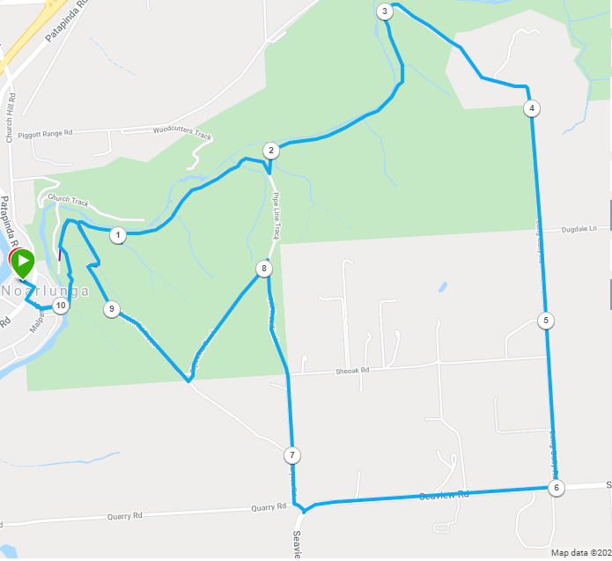
Directions:
- From the park, run towards the suspension bridge and cross over, turning left onto the single track
- Continue to follow the track as it continues along the wider trail/road to the bottom of Old Coach Road
- Take the Gorge track, to the left and continue to follow it till you reach the Pipeline
- Turn left down the pipeline and then right onto the Gorge track (single track)
- Continue to follow the Gorge track for approx. 1km till you reach the road to the right
- Turn right and go up hill, passing the gun club and continue along the road out to Seaview Road (Main road)
- Turn right and follow Seaview road for approx. 1km
- As Seaview Road swings to the left, turn right into Barytes Road, then right straight away and continue until you reach the national park fence
- Enter the park and continue straight ahead along Tea Tree track for a short distance, then take a sharp left turn and follow until the park gate (left) and Old Coach Road (Right)
- Turn Right and follow Old Coach Road back down the hill
- At the bottom, continue to the left back to the suspension bridge and the park

