Course maps and directions courtesy of Trail Running SA: <http://trailrunningsa.com/scott-creek-conservation-park/>

**Eastern Loop 12 kms**

**Garmin course map:** [**https://connect.garmin.com/modern/course/21638616**](https://connect.garmin.com/modern/course/21638616)

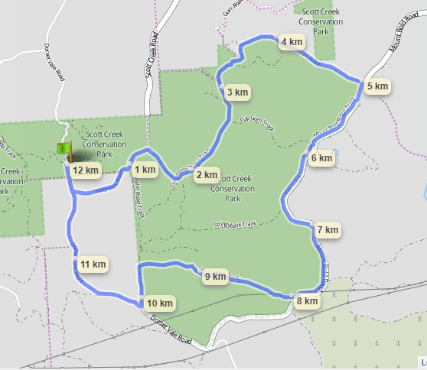

§ From Almanda Ruins car park on Dorset Vale Rd head south for 300m towards junction with Matthews Rd.

§ Turn left  into Matthews Rd, and proceed almost one km.

§ Turn right into the Park at gate signposted Bandicoot Track.

§ Proceed to junction with Currawong Ridge Track; turn left.

§ Proceed to junction with Cup Gum Track, turn left and follow this through to a gate out of the Park.

§ Go through gate, and turn right up a long, gradually climbing dirt road (Gurr Rd) to junction with bitumen road which is Mt Bold Rd.

§ Turn right, and after c.200m turn right, climbing over a gate back into the Park.

§ Turn left along Mt Bold Ridge Track, which runs beside Mt Bold Rd for 2.8kms until you come to sign saying Shingleback Track.

*§ On the way ignore signs into Cup Gum Track and Stringybark Track.*

§ The track bears right and becomes Shingleback Track, and goes downhill to junction with track called Neville Rd

§ Turn left and proceed to junction with Dorset Vale Rd (Bitumen). Turn right and proceed for c.2.5kms to the starting point.

**Western Loop 4.6 kms**

**Garmin course map:** [**https://connect.garmin.com/modern/course/21638640**](https://connect.garmin.com/modern/course/21638640)

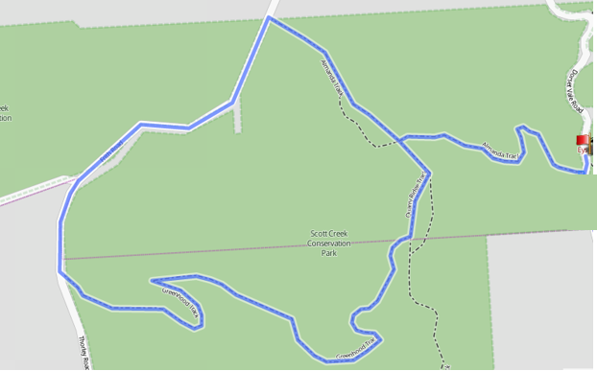

§ From the parking area, proceed up Almanda Track until the top of the hill and T-section (sign for old Helipad).

§ Take first left onto Quarry Ridge Track, then first right into Greenhood Track just past the quarry.

§ Continue along the track, and at the top of Greenhood Track you reach a gate leading into a dirt road. Turn right and follow this to Frith Rd (approx. 300 metres).

§ Turn right and continue for about 600 metres until Gate 18 on the right. This is Almanda Track. Follow this back to the start (remember to turn left back down to the carpark at the T-section with Quarry Ridge track/Helipad site).