SRG 6.5km Sturt Gorge loop
https://connect.garmin.com/modern/course/138013172
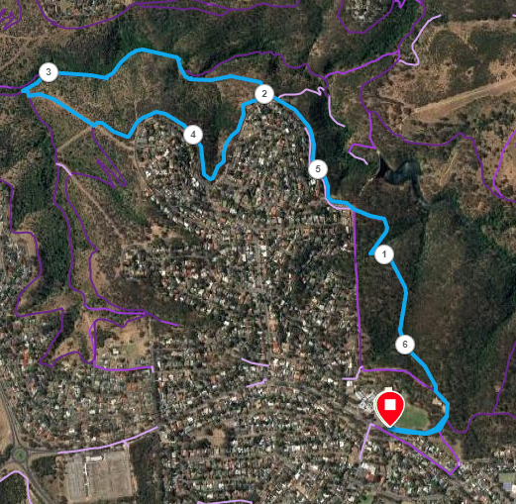
Directions
- Starting from the car park near Flagstaff Hill Primary School oval, take the private road alongside the oval and pass the back of the Scout Hall. Entering the trail from the back
- Follow the diagonal trail for 1km, mostly downhill.
- Just after 1km take the trail to the right and then to the left as it joins the perimeter track nearest to the houses
- At the 2kn Mark, turn right down into the gorge, along Perrianna track.
- At the bottom, keep the river on your right side and continue along the rivers edge till approx. 3.1km and then take the track (Marked Adelaide 100) to the left
- After a very short distance take the small track to the left which leads you to a steep wide track until another track crosses over this track, then turn left
- Follow the perimeter track and then, at about 5.2km follow the same track you started on back to the Scout Hall and start point.

SRG 11.5km Sturt Gorge loop
https://connect.garmin.com/modern/course/138013167
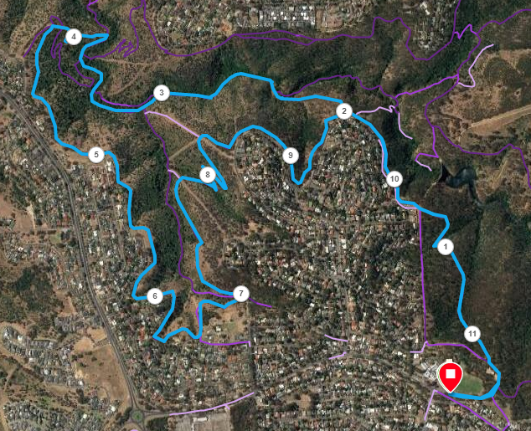
Directions
- Starting from the car park near Flagstaff Hill Primary School oval, take the private road alongside the oval and pass the back of the Scout Hall. Entering the trail from the back
- Follow the diagonal trail for 1km, mostly downhill.
- Just after 1km take the trail to the right and then to the left as it joins the perimeter track nearest to the houses
- At the 2kn Mark, turn right down into the gorge, along Perrianna track.
- At the bottom, keep the river on your right side and continue along the rivers edge past the Adelaide 100 sign
- At the 3.8km mark, turn left and follow the track up and around until unning back (in the opposite direction) close to the perimeter, near the houses
- Stay on the perimeter track continuing near the houses until just after the 10km point and then follow the same track you started on back to the Scout Hall and start point.

