SRG 6.1km McLaren Flat loop
https://connect.garmin.com/modern/course/123895069
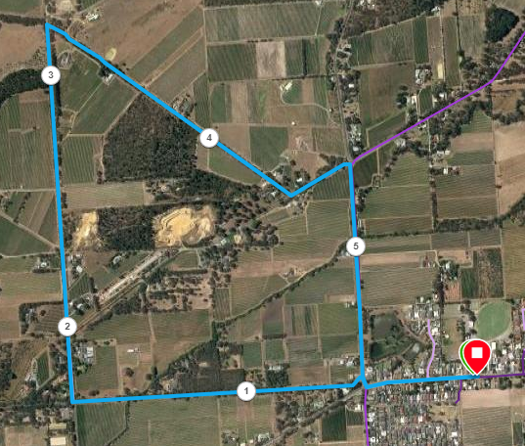
Directions
- Follow Main Road until Blewitt Springs Road, then turn right and immediately left onto Chalk Hill Road.
- Follow till Foggo Road (1.7km point) and turn right
- Run until Settlement Road (3.2km point) and take sharp right turn
- At Penney’s Road, turn left
- After 300 metres turn right onto Blewitt Springs Road
- At Main Road turn left and return to the start

SRG McLaren Flat 11.4km loop
https://connect.garmin.com/modern/course/123893838
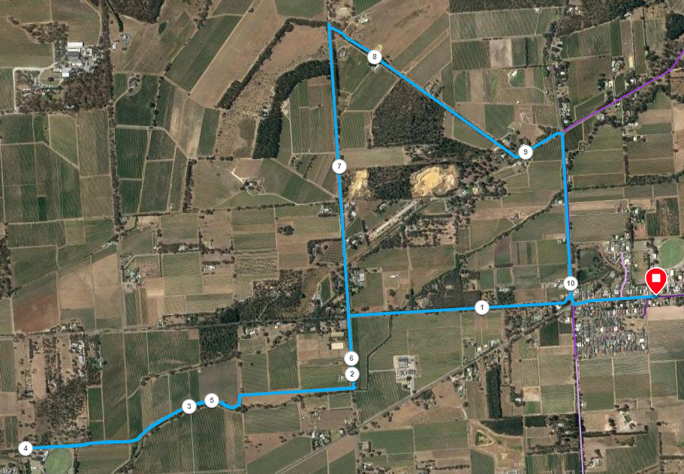
Directions
- Follow Main Road until Blewitt Springs Road, then turn right and immediately left onto Chalk Hill Road.
- Follow till Foggo Road (1.7km point) and turn LEFT
- After 400 metres, turn right onto the bike track and follow it until near McLaren Vale Oval (4km point)
- Turn back and run to Foggo road again then turn LEFT
- Run until Settlement Road (7.7km point) and take sharp right turn
- At Penney’s Road, turn left
- After 300 metres turn right onto Blewitt Springs Road
- At Main Road turn left and return to the start

SRG 20.6km McLaren Flat loop

https://connect.garmin.com/modern/course/123896148
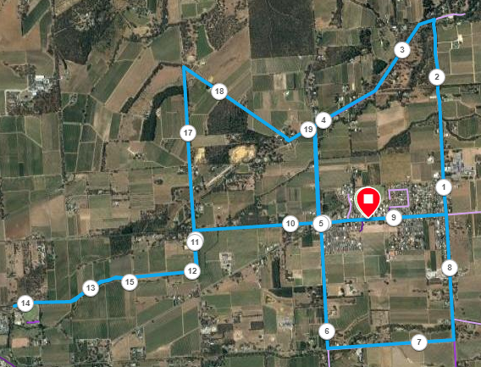
Directions
- Follow Main Road towards Kangarilla and turn left onto Ingolby Road (700 metre point)
- Run until the T-Section with Blewitt Springs Road (2.5km) and turn left
- Follow Blewitt Springs Road back to Main road (turns to the left near Whitings and Penney’s Roads)
- Continue across Main Road and run until Sand Road (approx.. 6.3km)
- Turn left and follow Sand Road until Oakley road and turn left
- Follow Oakley Road until Main Road
- At Main Road turn left and return to the start

10km run start point
- Follow Main Road until Blewitt Springs Road, then turn right and immediately left onto Chalk Hill Road.
- Follow till Foggo Road (1.7km point) and turn LEFT
- After 400 metres, turn right onto the bike track and follow it until near McLaren Vale Oval (4km point)
- Turn back and run to Foggo road again then turn LEFT
- Run until Settlement Road (7.7km point) and take sharp right turn
- At Penney’s Road, turn left
- After 300 metres turn right onto Blewitt Springs Road
- At Main Road turn left and return to the start

